


Applied Machine Learning (Assignment # 3)

Submission: 12-22-2025 | Marks: 10 | Semester: Fall 2025
Course Code: SECP2043 | Course Instructors: Dr. Ali Saeed

Assignment must be submitted using CMS portal

Question # 1. [Marks 10]
Develop a Flask based web application with following pages. Web application contains both front end and backend with following web pages:

- Main Page
  - Contains the link of various services (example web page design is given, however you can chose any other beautiful design)
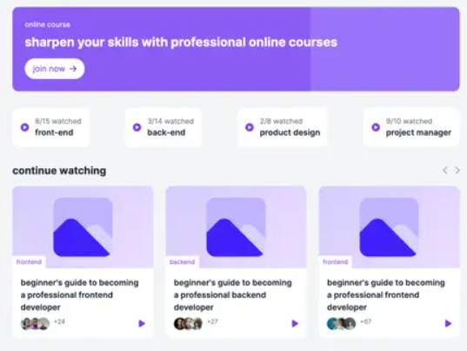
Models to implement:
- Image classification Male and Female image classification using CNN
- Sentiment Analysis (Input is Voice and output is text) using Transformers
- Question Answering (Both input and output is voice) using Transformers
- Text Generation (Input and Output is text) using Transformers
- Translation (from English to Urdu) using Transformers

